ADC Resolution vs Sensor Less Motor Control Performance

Cristian Ornelas

Tyler Hawkins

Tamara Hussam A Basfar

John Adam King

**Concept of Operations**

REVISION – 3

05 December 2024

Concept of Operations

for

ADC Resolution vs Sensor Less Motor Control Performance

Team <1>

Approved by:

_____________________________

Project Leader Date

_____________________________

Prof. Kalafatis Date

_____________________________

T/A Date

**Change Record**

| **Rev.** | **Date** | **Originator** | **Approvals** | **Description** |
| --- | --- | --- | --- | --- |
| **1** | [9/15/2024] | [ADC Resolution vs Sensor Less Motor Control Performance] |  | Draft Release |
| **2** | [9/26/2024] | [ADC Resolution vs Sensor Less Motor Control Performance] |  | Second Revision |
| **3** | [12/04/2024] | [ADC Resolution vs Sensor Less Motor Control Performance] |  | Third Revision |

**Table of Contents**

**Table of Contents III**

**List of Figures** **I****V**

**1.** **Executive Summary 1**

**2.** **Introduction 2**

2.1. Background 2

2.2. Overview 3

2.3. Referenced Documents and Standards 4

**3.** **Operating Concept 5**

3.1. Scope 5

3.2. Operational Description and Constraints 6

3.3. System Description 7

3.4. Modes of Operations 7

3.5. Users 8

3.6. Support 8

**4.** **Scenario(s) 8**

4.1. Unfavorable/ Extreme conditions 8

4.2. Cheaper Alternative 8

**5.** **Analysis 9**

5.1. Summary of Proposed Improvements 9

5.2. Disadvantages and Limitations 9

5.3. Alternatives 9

5.4. Impact 10

**List of Figures**

Figure 1. Simplified subsystem flow diagram………………………………………..…………1

Figure 2. Project synopsis…………………………………………………………………..……2

Figure 3:Block Diagram of System ...…………………………………………..……………….5

# 

# 1.0 Executive Summary

The focus of our project is to develop software for the c2000 TI chip to implement sensorless field-oriented motor control for motor systems. A microcontroller will be used to estimate the position of the rotor instead of traditional sensors. To improve and optimize motor position estimation the ADC resolution will be increased. Testing will be conducted under various conditions such as different motor speeds to evaluate how improved ADC resolutions impact the accuracy of position estimation. To test accuracy results from the sensorless motor controller will be compared to an incremental encoder.

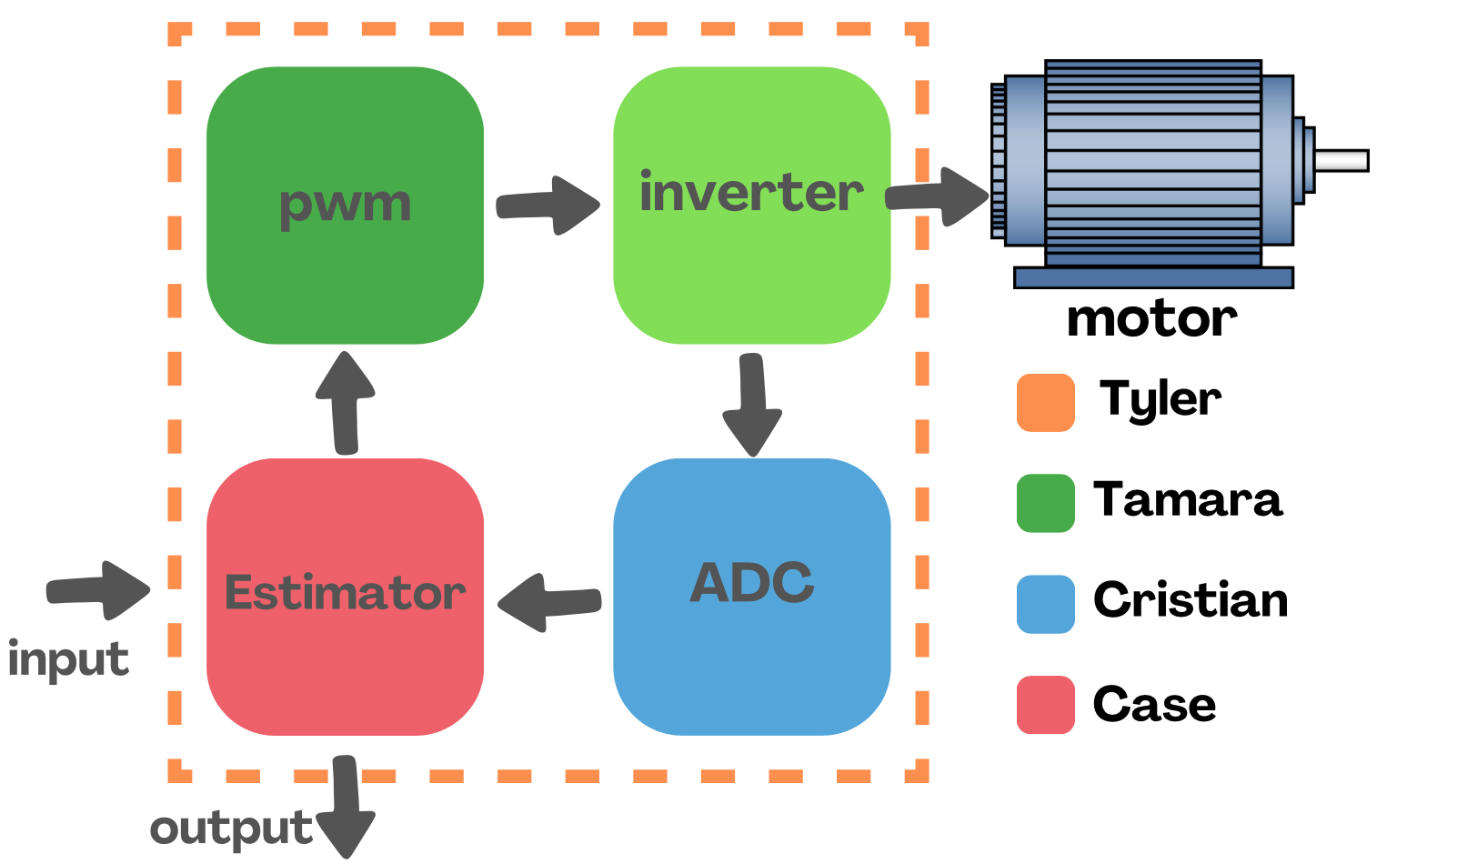

*Figure 2*. Simplified subsystem flow diagram

# 

# 

# 2.0 Introduction

## 2.1 Background

The most common motor design today is the Brushed DC Motor and the Brushless(BL) DC Motor. The brushed DC motor works by using mechanical logic and brushes to deliver electricity to the stator so that the motor spins, however, these brushes bend over time and reduce contact with the rotor. The BLDC motors often use Hall Effect sensors to detect where the rotor is, and this information is fed either into a microcontroller or analog circuit that will then control which magnets receive electricity in the stator. These motors are widely employed in all areas, but as more fields require precision motor controls, these designs have become insufficient.

The sensorless motor design aims to remove the need for sensors by using the feedback emf, electromotive force, of the motor and using this information to estimate the position of the rotor. This will allow the motor to operate with enhanced accuracy as an angle can be given for the orientation of the rotor as opposed to a region, and reduce the overall number of components needed for the motor to function.

## 

## 2.2 Overview

The full system code will implement sensorless field-oriented control (FOC) of a motor. Our team will be provided hardware for the project, a motor/ motor controller, and a software development kit provided by Texas Instruments.

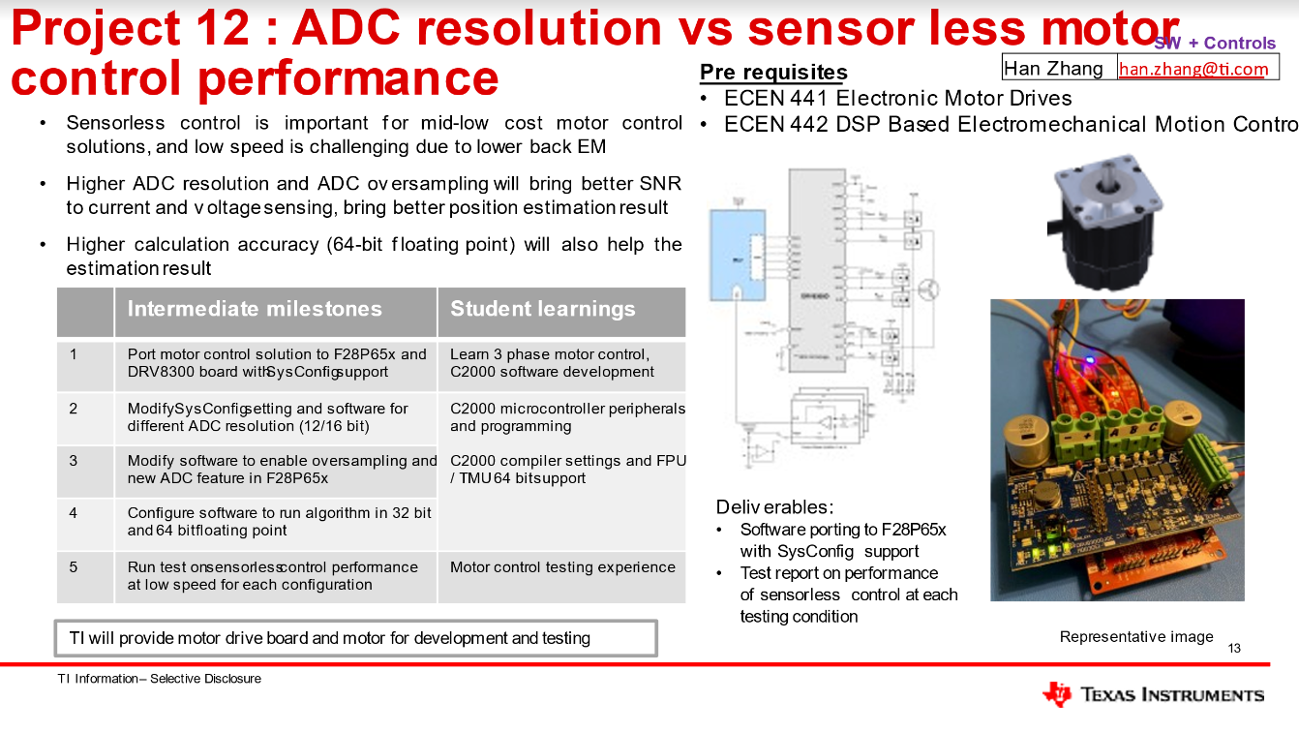

*Figure 2*. Project synopsis

To begin, we will port software to the F28P65x board with SysConfig support. Next, we will be implementing code to estimate the angle of the motor and load it onto the motor controller. To output results, our group will perform the first round of tests on the software that measures the motor operating with different ADC resolutions at low motor speeds. To be more precise, we will be performing additional tests on the software by enabling oversampling and 32/64-bit floating-point operators. The results will also be recorded at low motor speeds. Once this is completed, we will repeat our process at various motor speeds to capture a wide range of operating conditions that our sensorless motor could be in in the real world. Progress on developing the code and test results will be documented; this information is presented on the project as our final results.

The findings of this project should be the comparison between ADC resolutions and their effect on estimating the position accuracy. This will provide valuable insight into optimizing motor control for lower costs and how we can use this innovation to positively impact our environment and the intended users. Below is a breakdown of our team’s subsystems:

**Subsystem 1**: PWM - Tamara

**Subsystem 2**: Estimator - Case

**Subsystem 3**: ADC Driver - Cristian

**Subsystem 3**: Porting - Tyler

## 2.3 Referenced Documents and Standards

1. *Motor Control Compendium*, <https://www.ti.com/download/trng/docs/c2000/TI_MotorControlCompendium_2010.pdf> Accessed 13 Sept. 2024.
2. “Analog-to-Digital Converter (ADC)#.”*Analog-to-Digital Converter (ADC) - C28x Academy*, [dev.ti.com/tirex/explore/content/c28x_academy_1_00_00_00/_build_c28x_academy_1_00_00_00/source/c2000_analog_subsystem/c2000_analog_to_digital_converter.html.](http://dev.ti.com/tirex/explore/content/c28x_academy_1_00_00_00/_build_c28x_academy_1_00_00_00/source/c2000_analog_subsystem/c2000_analog_to_digital_converter.html) Accessed 13 Sept. 2024.
3. “Sensor vs Sensorless Motor Controllers: A Head-to-Head Comparison.” *Solo Motor Controllers*, 27 Jan. 2024, [www.solomotorcontrollers.com/blog/sensor-vs-sensorless/?srsltid=AfmBOooTJsLnUA1zI53QF1GIPMYkBLSi7XJWOyLefSThTds0uwlZ2OQw.](http://www.solomotorcontrollers.com/blog/sensor-vs-sensorless/?srsltid=AfmBOooTJsLnUA1zI53QF1GIPMYkBLSi7XJWOyLefSThTds0uwlZ2OQw)
4. *User's Guide Motor Control SDK Universal Project and Lab,* <https://www.ti.com/lit/ug/spruj26a/spruj26a.pdf?ts=1727366836338&ref_url=https%253A%252F%252Fwww.google.com%252F>
5. *DRV8300: 100-V Three-Phase BLDC Gate Driver datasheet (Rev. D),* <https://www.ti.com/lit/ds/symlink/drv8300.pdf?ts=1729946514499>
6. *TMS320F28002x Real-Time Microcontrollers datasheet (Rev. C),* <https://www.ti.com/lit/ds/sprsp45c/sprsp45c.pdf?ts=1729987040570&ref_url=https%253A%252F%252Fwww.ti.com%252Ftool%252FLAUNCHXL-F280025C>
7. *TMS320F28P65x Real-Time Microcontrollers datasheet (Rev. B),* <https://www.ti.com/lit/ds/symlink/tms320f28p650dk.pdf?ts=1729638180938&ref_url=https%3A%2F%2Fwww.ti.com%2Fproduct%2FTMS320F28P650DK>
8. *TMS320F28P65x Real-Time Microcontrollers Technical Reference Manual (Rev. B),* <https://www.ti.com/lit/ug/spruiz1b/spruiz1b.pdf?ts=1731304485120&ref_url=https%253A%252F%252Fwww.ti.com%252Fproduct%252FTMS320F28P650DK>
9. *TMS320F28002x Real-Time Microcontrollers Technical Reference Manual (Rev. C),* <https://www.ti.com/lit/ug/spruin7c/spruin7c.pdf?ts=1731455337533&ref_url=https%253A%252F%252Fwww.google.com%252F>
10. *LAUNCHXL-F28P65X LanchPad Box Sticker and Insert,* <https://www.ti.com/lit/ml/spaz022/spaz022.pdf?ts=1730999920772&ref_url=https%253A%252F%252Fwww.ti.com%252Ftool%252FLAUNCHXL-F28P65X>
11. *LAUNCHXL-F28P65X Schematic,* <https://www.ti.com/lit/df/sprr480/sprr480.pdf?ts=1729638767085>
12. *LAUNCHXL-F280025C Schematic (Rev. A),* <https://www.ti.com/lit/df/sprr425a/sprr425a.pdf?ts=1730854635311&ref_url=https%253A%252F%252Fwww.google.com%252F>
13. *LAUNCHXL-F280025C Quick start guide,* <https://www.ti.com/lit/ug/spruiw5/spruiw5.pdf>

# 3.0 Operating Concept

## 3.1 Scope

The ADC sensorless motor control performance will be designed to fit the proper parameters for professionals to carry out the finished product. The milestones for the scope are listed below:

* Port motor control solution to F28p65x and DRV8300 board with SysConfig support
* Modify SysConfig setting and software for different ADC resolutions (12/16 bit)
* Modify the software to enable oversampling and new ADC feature in F28p65x
* Configure software to run an algorithm, in 32-bit and 64-bit floating point
* Run tests on sensorless control performance at low speed for each configuration

The focus of the project will be on the development and testing of the control system under different testing conditions.

## 3.2 Operational Description and Constraints

Sensorless Motor control allows a user to control a motor's operations without the use of any onboard sensors. The software created will be able to determine the motor's position, speed, and torque using in/out current and voltage. The following diagram shows the flow of software operations used to control the motor.

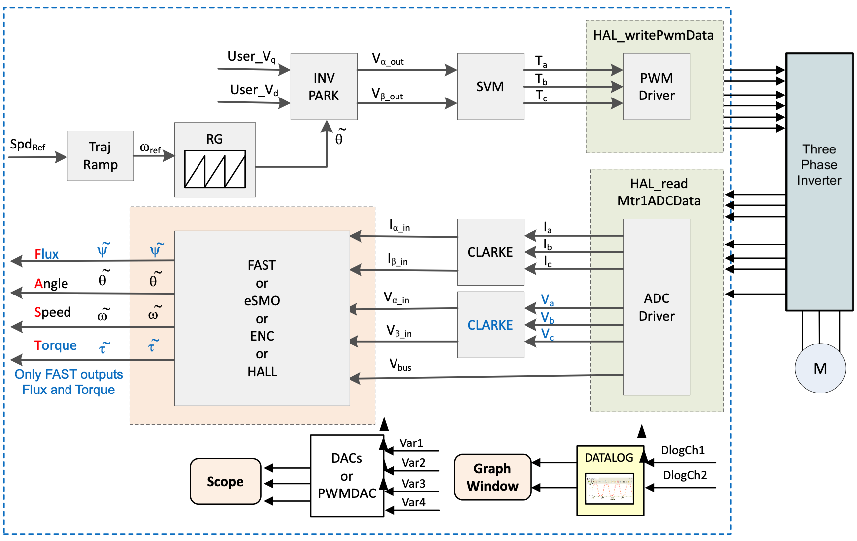

*Figure 3. Block Diagram of System*

The resulting constraints from this operational description are as follows:

* The Motor should be able to be controlled without any sensors
* The ability to control the motor using both 12 & 16-bit resolution
* The ability to control the motor using both 32 & 64-bit floating point operations
* All code used to control the motor should run on TI’s F28P65x Launchpad board and the DRV8300 motor driver board.
* All software should be able to be configured using sysconfig

## 3.3 System Description

* Microcontroller and Estimater Code: The microcontroller contains the code that will take the input voltage and current to estimate the position of the rotor. The code itself will operate by taking these values, calculating using the back EMF feedback, then force on the motor, and then using this data in conjunction with its internal clock to calculate the angular orientation of the rotor. This data will then be fed back to the connected computer, as well as the motor controller. The resulting rotor angle and speed are used for real time control purposes.
* Motor Controller and control code: The motor controller will take the position data of the rotor and determine which poles should then be powered to provide a continuous force on the rotor. This subsystem includes a module that manages the motor operation at high speeds, a controller regulating phase currents to achieve desired torque and speed, and a module that converts the reference voltage vectors into PWM signals.
* Motor: The motor is being driven by the motor controller, but is also the driving force behind the calculations run in the microcontroller. The motor operates through electrical to mechanical conversion, converting signals from the inverter to mechanical rotation, the torque generated is directly influenced by the supplied currents. Another key part of its operation are the resulting electrical motor characteristics that are imputed back into the estimate creating a feedback loop that is essential for real-time position and speed control without sensors.

## 

## 3.4 Modes of Operations

The software is designed to cooperate utilizing an input ADC resolution to control the size of each sample taken by the microcontroller when calculating the rotor position. ADC resolution refers to how many bits are used for each data point. While any input is theoretically possible, the system will be tested on 32-bit and 64-bit resolutions. Additionally, the motor will operate in closed or open loop controls. In an open loop, the microcontroller will only use the BackEMF to determine the rotor position. In closed loop however, the previous estimation will be fed back into the estimation software and used in the next position test.

## 

## 

## 3.5 Users

The sensorless motor control system is intended for users who work with sensored motors and want to reduce the cost of production. Whether it’s electric vehicle manufacturers who want to minimize complexity and increase reliability or HVAC engineers who wish to optimize fan motors, sensorless motors will revolutionize motor control. The intended users must have some intermediate to advanced knowledge of this system. They must understand basic motor control principles such as field-oriented control, programming languages like C++, error analysis, ADC resolution settings, etc.

## 3.6 Support

Support for the sensorless motor will be supplied in a user manual providing detailed instructions/ information on how to function the sensorless motor control system. There will also be troubleshooting guidance if the system doesn’t work as intended.

# 

# 4.0 Scenario(s)

## 4.1 Unfavorable/ Extreme Conditions

Without the need for any sensors, a sensorless controlled motor can operate much more reliably in harsher conditions. Motor sensors can often run into issues in environments whose variables frequently change. An example of this is frequent temperature fluctuations within an environment can often mess with the accuracy of a sensor. A sensor is also another point of failure for the motor within a harsh environment. Without the sensor, the motor is less likely to fail within these conditions.

## 4.2 Cheaper Alternative

Removing sensors from a motor within a device brings the cost down for that component. Examples commonly seen today include Electric transportation, such as E-bikes & scooters, Drones, and other robotic devices. A sensorless motor makes purchasing these devices more accessible to an everyday consumer, due to the cost reduction when compared to a sensored motor.

# 5.0 Analysis

## 5.1 Summary of Proposed Improvements

* Elimination of physical sensors for position estimation: This reduces hardware costs, and simplifies maintenance by reducing points of failure.
* Smaller motor designs: By eliminating physical sensors, the system enables more compact motor designs, saving space in applications.
* Increased flexibility and reliability: Sensorless motor control allows for a more flexible and reliable system due to fewer parts susceptible to damage; they have higher lifespans and can be used in harsh environments.
* Increasing ADC resolutions: an increased ADC resolution can potentially improve control speed precision which can improve performance at lower motor speeds.
* Optimal configuration identification: By testing the system at low and high speeds, the system will help identify optimal configurations for accurate position estimation and motor control.
* Environmental benefits: The system has the potential to contribute to energy-efficient designs and lower material costs, making it a more sustainable solution.

## 5.2 Disadvantages and Limitations

* Performance limitations at very low speeds due to lower back EMF
* sensorless motor controls use advanced algorithms which can complicate the control system needing a more sophisticated microprocessor.
* longer development time due to the need for calibration and testing.

## 5.3 Alternatives

* Hall effect motors: use hall effect sensors to detect the magnetic field from the rotor to estimate the position.
* Incremental motors: uses three wave pulses for position detection.
* Tachometer motor: uses speed sensors to estimate rotor position.
* Potentiometer motors: use a potentiometer to measure the angular displacement and estimate the position of the rotor.
* LVDTs: use linear differential transformers to sense linear displacement in some motors to estimate the rotor position.

These motor controllers have their advantages but are more costly and space-consuming.

## 

## 

## 5.4 Impact

The impact of this technology would be a reduction in the cost and material needed in precision motor applications, thus allowing more to be done for less. Overall, the impact on the environment and society would be quite small, though it would act as another point towards the idea of streamlining current technologies to use only the materials that they require.